Carti Hotel Management System

Version 1.0

Revision History

|  |  |  |  |
| --- | --- | --- | --- |
| **Date** | **Version** | **Description** | **Author** |
| 24/11/2024 | 1.0 | Final Version | Nguyen Huu Dang |
|  |  |  |  |
|  |  |  |  |
|  |  |  |  |

Table of Contents

1. Use-Case Name 4

1.1 Brief Description 4

1.2 Actor 4

2. Flow of Events 4

2.1 Basic Flow 4

2.2 Alternative Workflows 5

3. Special Requirements 5

4. Preconditions 5

5. Postconditions 5

6. Extension Points 5

7. Prototype 5

# Use-Case Name

## Brief Description

This use case allows a customer to prepay money through a banking application or credit card for the  
rooms that he/she has reserved previously.

## Actor

Customer.

# Flow of Events

## Basic Flow

The process begins when the customer clicks the **Make Payment Now** button. The system then displays a list of available payment methods, from which the customer selects their preferred option. Based on the chosen method, the customer enters the necessary payment information. The system processes the payment, and if successful, sends the booking details via email and displays a success message. If the payment fails, the system displays an error message, offering the customer two options: to retry the payment or defer it for later.

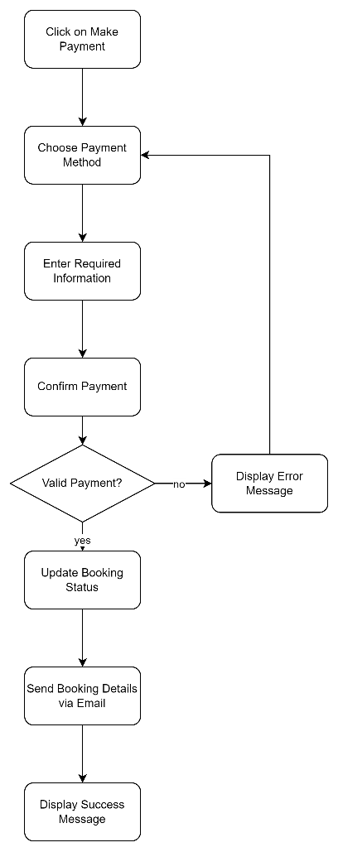

## Alternative Workflows

None.

# Special Requirements

None.

# Preconditions

The user has successfully logged in as Customer.

# Postconditions

NA.

# Extension Points

NA.

# Prototype

1. On the Confirm Booking Page, the customer clicks on the green **Make Payment Now** button to process the payment

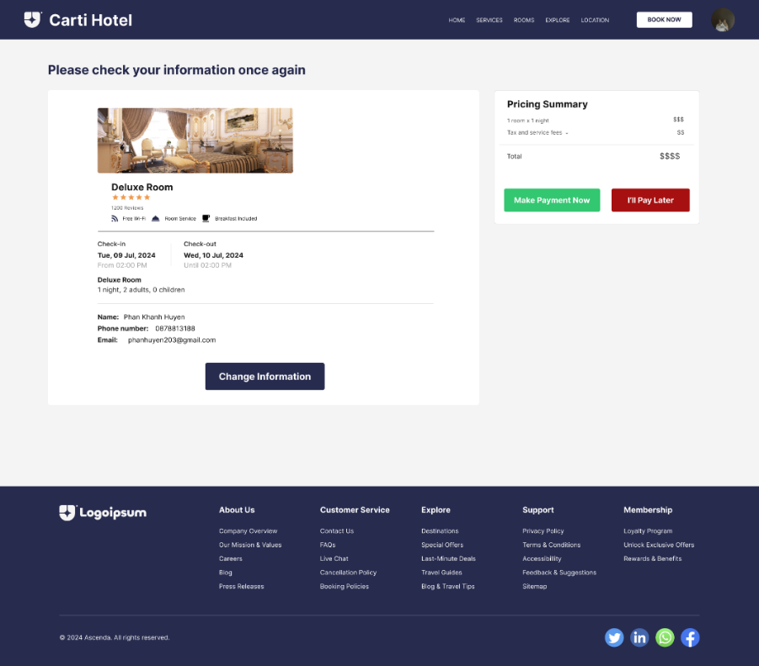

2. After clicking **Make Payment Now** a modal is displayed with available payment methods. The customer selects a method and click **Continue**

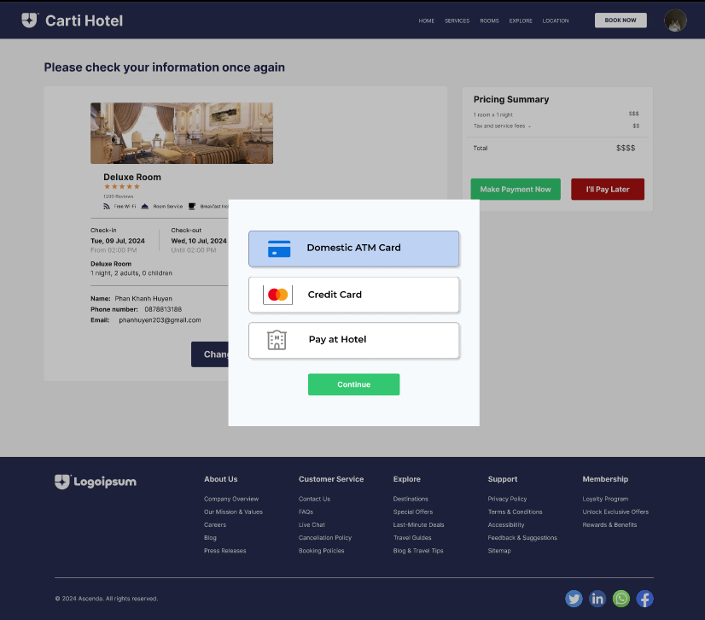

3. After selecting a payment method, the customer is required to enter information based on which method they selected. After filling all the required fields, the customer clicks **Make Payment**

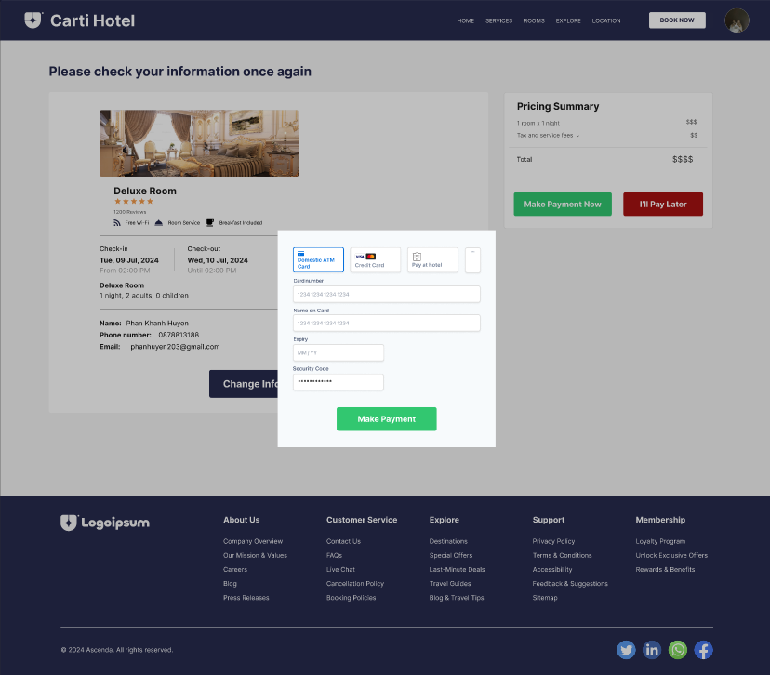

4. The customer confirm the payment. For example, providing PIN for Domestic ATM Card payment method.

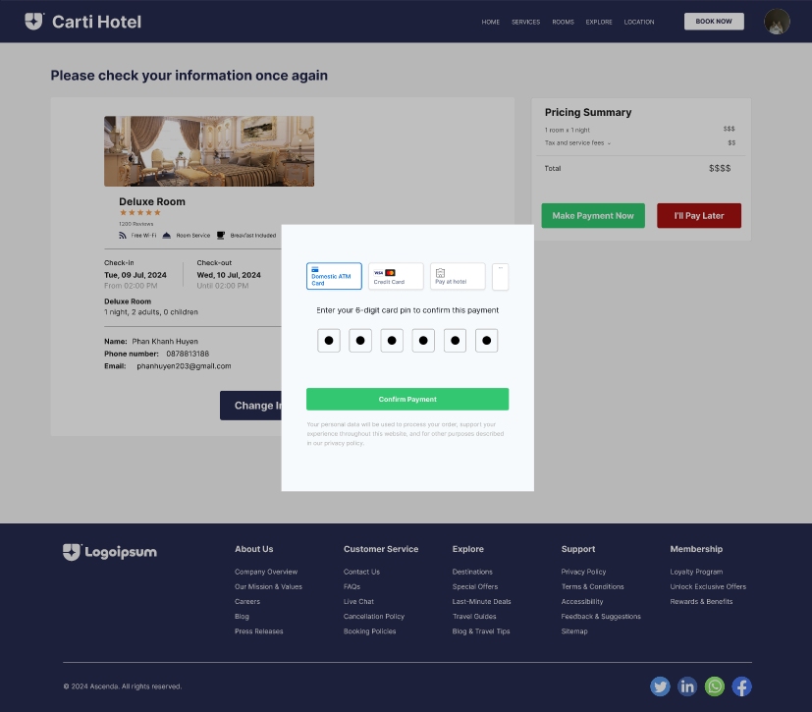

5. The system displays message to notify whether the payment is successful or not. 